Theories about the origin of life

Tomasz Zajkowski ^{abc}

ª Centre of New Technologies, University of Warsaw, Banacha 2c, 02-097 Warsaw, Poland
^{b} University Space Research Association, 615 National Ave, Suite 220, Mountain View, CA 94043
^{c} Blue Marble Space Institute of Science, 600 1st Avenue, Seattle, Washington 98104, USA

email: t.zajkowski@cent.uw.edu.pl

In 1920 two researchers J. B. S. Haldane and Aleksandr Oparin, envisioned that complex organic compounds formed from simpler inorganic precursors. This theory was called abiogenesis. But this idea had no scientific support until Stanley Miller and Harold Urey conducted their famous experiment in which they simulated the conditions on early Earth by mixing water vapor, hydrogen, methane, and ammonia. They passed these gases through glass tubes treating them with electric discharges. After some time they observed the formation of complex organic compounds such as amino acids - that are the basic building blocks of proteins. Their experiment in various variants is still carried out today in many laboratories. Recently, using a similar approach, scientists were able to show production of nucleotides - the basic building blocks of DNA and RNA (Ferus et al. 2017). The most important in the Miller-Urey experiment is the discovery that from simple compounds, one can easily create matter that is the basis of life. Yet even the simplest bacterium alive today is extremely complex, and it is difficult to imagine that it could arise in such a simple experiment as Miller and Urey devised. There must have been intermediate steps in life's history that did not survive until today. Because all life on Earth is related to each other, traces of what the first organisms might have looked like could have survived in organisms that live today.

We don’t know how exactly life began, mostly because the geological record of that period is lost, but we have many hints as to what could have happened. To give the reader an overview of some popular concepts, in this article, I will ask a series of fundamental questions: When did life begin? What is life? What was first: DNA or proteins? Where did life begin?

When did life begin?
Certainly, life on Earth could not have started before the Earth itself formed 4 billion 456 million years ago. Soon after our planet was formed, it collided with another planet about the size of Mars (Bottke et al. 2015). This event melted the crust and led to the formation of the Moon. When the Earth's crust cooled again, there might have already been water on its surface (Mojzsis et al. 2001), not for long though, because over the next several hundred million years, hundreds of massive meteors fell on Earth. This period was called the great bombardment. As a result of the collisions, the hypothetical oceans evaporated, and the Earth's crust melted again. At that time, the Earth just wasn't a good place to live, at least until bombardment stopped about 4 billion years ago - this is the earliest possible time for life to begin on our planet.

Fossils and chemical evidence show that microorganisms already existed on Earth about 3.5 billion years ago (Shopf et al. 2007). This means that inanimate matter became living matter at about this time. There is also a controversial evidence that life on Earth was already present 4.1 billion years ago (Bell et al. 2015). Figure 1 is a transmission X-ray image of 4.1 billion-year-old zircon with graphite embedded in it. This graphite has a carbon isotope typical of living organisms, but it is not strong evidence for life. Microfossils such as shown in Figure 2 are stronger evidence (Shopf et al.2007). This figure also gives us the idea that if we could go back in time to look for the first organisms, it might be problematic to recognize them. This brings us to the next unanswered question – what is life?

What is life?
Origin of what are we trying to understand? Surprisingly the answer to this question is not trivial even to biologists. Fortunately, understanding life's definition is not necessary to study its origin - an idea explained by Nobel laureate Jack Szostak in one of his publications (Szostak 2012). Perhaps the whole difficulty in answering this question, is due to the fact that we formulate it incorrectly. Perhaps life is not something that living organisms have, but rather something that living organisms do. Maybe instead of asking if something is alive, we should ask how much it is alive.

In 1944 physicist Erwin Schrödinger looked at what living organisms do and noted that according to the second law of thermodynamics, the universe tends to increase its entropy. Energy and matter tend to dissipate and simplify and yet, inside a living cell, everything is hugely complex and highly ordered. Schrödinger defined life as: counteracting entropy or maintaining disequilibrium.
In his view living organisms are little closed chemical systems that work to maintain order, but this definition ignores one important feature of living organisms: living organisms evolve.
It is widely agreed that the first living organism must have had information stored in some way. Instructions on how to build its individual components. These molecules are presumed to be polymers capable of building bigger structures out of smaller components. Modern cells use polymers for a variety of functions including information storage (e.g., DNA, RNA), or structural (e.g., actin, tubulin). The process of forming a polymer occurs also outside the cells. For example, RNA chains polymerize on mineral surfaces (Pearce et al. 2002). The RNA chain is formed from building blocks found in the environment. Because the resulting chains differ from each other they interact differently with the environment. For example some will be more effective at obtaining their building material than others and therefore exhaust the resources of subunits faster - limiting the growth of competing chains of polymers. This process is very similar to biological evolution by natural selection but is happening in a purely chemical context. It seems that for life to develop - evolve - and even originate, natural selection had to exist from the very beginning. In chemistry this process is called chemical evolution. It seems reasonable to conclude that life is a product of evolution. Life probably began when molecules began to copy and evolve through natural selection. Life can thus be defined as a self-sustaining chemical system capable of Darwinian evolution (Deamer and Fleischaker 1994). This working definition has its flaws but using it, allows us to describe what should characterize living organisms, either on early Earth or on other planets or moons.

In summary life should counteract entropy. To do this, it should create a closed system (for example be made of cells). It should have some kind of molecule capable of carrying information. Information on how to build its components. And this information should be able to evolve through natural selection.

What was first: the DNA or Proteins?
When we look at living organisms, no matter where they are on the phylogenetic tree of life, most cellular machinery is made of proteins. Our cells, like all known organisms on our planet, to produce proteins, must copy genes from deoxyribonucleic acid (DNA) to ribonucleic acid (RNA) and use RNA as a template for producing proteins. This universal mechanism is called the "central dogma of molecular biology". There is a hidden paradox in this dogma - the sort of problem of what came first - the chicken or the egg? DNA needs proteins to replicate itself. Cells use DNA to make protein. Fortunately, when considering the origins of life, we can solve this paradox quite easily. The solution is to replace both DNA and proteins with RNA. RNA is a molecule related to DNA. It contains the same 4 letters of the genetic code, with the difference that thymine is replaced with chemically similar compound uracil. Instead of 2 strands and a helix, RNA usually has only one strand. RNA is unique because, in addition to its ability to carry information, it can also fold into complex shapes - similarly to proteins. As protein enzymes catalyze various chemical reactions, RNA enzymes - called ribozymes can also function as molecular machines.

A popular theory of the origins of life is the so-called „RNA world hypothesis” - a world where RNA performed both informational and catalytic functions. For the theory to be true, even if the RNA world is long gone, we should still be able to produce ribozymes synthetically. Indeed, artificial ribozymes that can copy their own sequence can be produced in laboratories (Paul and Joyce 2002). Copying is not 100% accurate, but errors are the basis of variability and natural selection. Another strong argument in favor of the RNA world hypothesis is that the ribosome (the molecular machine used to make proteins) is mostly made of RNA. RNA constitutes its oldest central part. Also, nucleotides, which are the RNA components, are found as part of many different molecules that the cell uses in metabolic processes, i.e., adenosine triphosphate (ATP), coenzyme A, or vitamina B12. Thus, the RNA world hypothesis has the potential to solve the chicken or egg question: RNA can store biological information, it can carry out enzymatic reactions, and it can evolve.

Where did life begin?
This question can be reduced to whether life arose on Earth or beyond it? Some studies suggest that microorganisms could survive in the vacuum of space and travel between planets (Nicholson 2009). The theory that life could have been delivered to our planet is called Panspermia. However, the Panspermia theory does not answer how life began but instead pushes it somewhere else. Therefore, in this article, I will assume that life arose here on Earth.

The universe is full of organic matter compounds that are delivered to the surface of Earth with meteorites or sub-mm grains (Kebukawa et al. 2017). This should come as no surprise when we realize that carbon is the fourth most abundant element in the universe. Life’s building blocks are widely available, but where exactly did life originate on Earth? Probably, somewhere where energy was present. The energy source for the first biochemical process could be the radiation from the Sun, the geothermal process, or electric discharge. We don’t know which one provided the energy for the first living systems, but maybe the clues needed to answer this question can be found in our own cells? We know that all life on Earth uses ATP to store energy. To produce ATP, cells accumulate hydrogen on one side of the membrane and enable the unidirectional flow of hydrogen atoms. They use this directional flow to generate a high energy bond in ATP utilizing a protein called ATP synthase. Maybe first, cells also used a hydrogen gradient to accumulate energy? Hydrothermal vents are an abundant source of hydrogen, and one of the places considered as the cradle of life. These underwater chimneys are additionally covered with microscopic pockets that could serve as molds for the first cells.

So, where did life begin? The answer is that we do not know, but let's assume for now that the first cell formed on the surface of a hydrothermal vent. Hypothetically, the energy released from the vent provided conditions for the first ribozymes to evolve. But the path to life as we know it remains very long. This primitive life had to replace information storage in RNA with DNA. Instead of using ribozymes, it had to start using proteins and it had to develop efficient ways of storing energy. The first life that acquired these features is referred to as the first universal common ancestor (FUCA) (Prosdocimi et al. 2019). Likely there were many organisms similar to FUCA but one of them eventually become the last universal common ancestor (LUCA) that originated the three domains of life: Bacteria, Archaea, and Eukarya (Woese 1998).

Although the origin of life theories have many missing parts, they are based on the processes we discovered or reproduced. In conclusion, it seems that life happens and will continue happening as long as the right conditions exist, on Earth or elsewhere.

Bell, Elizabeth A., et al. “Potentially Biogenic Carbon Preserved in a 4.1 Billion-Year-Old Zircon.” Proceedings of the National Academy of Sciences of the United States of America, vol. 112, no. 47, National Academy of Sciences, Nov. 2015, pp. 14518–21.
Bottke, W. F., et al. “Dating the Moon-Forming Impact Event with Asteroidal Meteorites.” Science, vol. 348, no. 6232, American Association for the Advancement of Science, Apr. 2015, pp. 321–23.
Deamer, David W., and Gail R. Fleischaker. Origins of life: the central concepts. Jones & Bartlett Pub, 1994.
Schopf, J. William, et al. "Evidence of Archean life: stromatolites and microfossils." Precambrian Research 158.3-4 (2007): 141-155.
Ferus, Martin, et al. “Formation of Nucleobases in a Miller–Urey Reducing Atmosphere.” Proceedings of the National Academy of Sciences of the United States of America, vol. 114, no. 17, National Academy of Sciences, Apr. 2017, pp. 4306–11.
Kebukawa, Yoko, et al. “One-Pot Synthesis of Amino Acid Precursors with Insoluble Organic Matter in Planetesimals with Aqueous Activity.” Science Advances, vol. 3, no. 3, American Association for the Advancement of Science, Mar. 2017, p. e1602093.
Mojzsis, Stephen J., et al. “Oxygen-Isotope Evidence from Ancient Zircons for Liquid Water at the Earth’s Surface 4,300 Myr Ago.” Nature, vol. 409, no. 6817, Nature Publishing Group, Jan. 2001, pp. 178–81.
Nicholson WL. Ancient micronauts: interplanetary transport of microbes by cosmic impacts. Trends Microbiol. 2009 Jun;17(6):243-50.
Paul, Natasha, and Gerald F. Joyce. “A Self-Replicating Ligase Ribozyme.” Proceedings of the National Academy of Sciences of the United States of America, vol. 99, no. 20, National Academy of Sciences, Oct. 2002, pp. 12733–40.
Pearce, Ben K. D., et al. “Origin of the RNA World: The Fate of Nucleobases in Warm Little Ponds.” Proceedings of the National Academy of Sciences of the United States of America, vol. 114, no. 43, National Academy of Sciences, Oct. 2017, pp. 11327–32.
Prosdocimi, Francisco, et al. “The First Universal Common Ancestor (FUCA) as the Earliest Ancestor of LUCA’s (Last UCA) Lineage.” Evolution, Origin of Life, Concepts and Methods, Springer, Cham, 2019, pp. 43–54.
Szostak, Jack W. "Attempts to define life do not help to understand the origin of life." Journal of Biomolecular Structure and Dynamics 29.4 (2012): 599-600.
Woese, Carl. "The universal ancestor." Proceedings of the national academy of Sciences 95.12 (1998): 6854-6859.

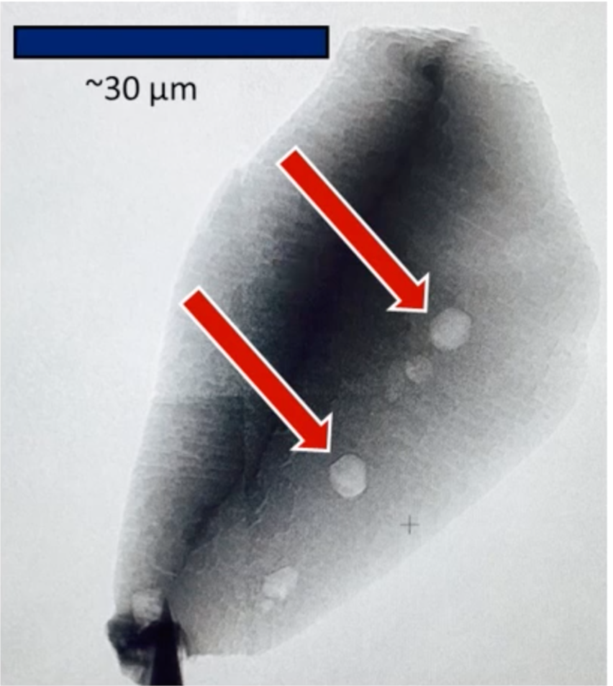
Fig. 1. Transmission X-ray image of zircon with graphite indicated. Image form Bell et al. 2015. Schopf et al. 2007

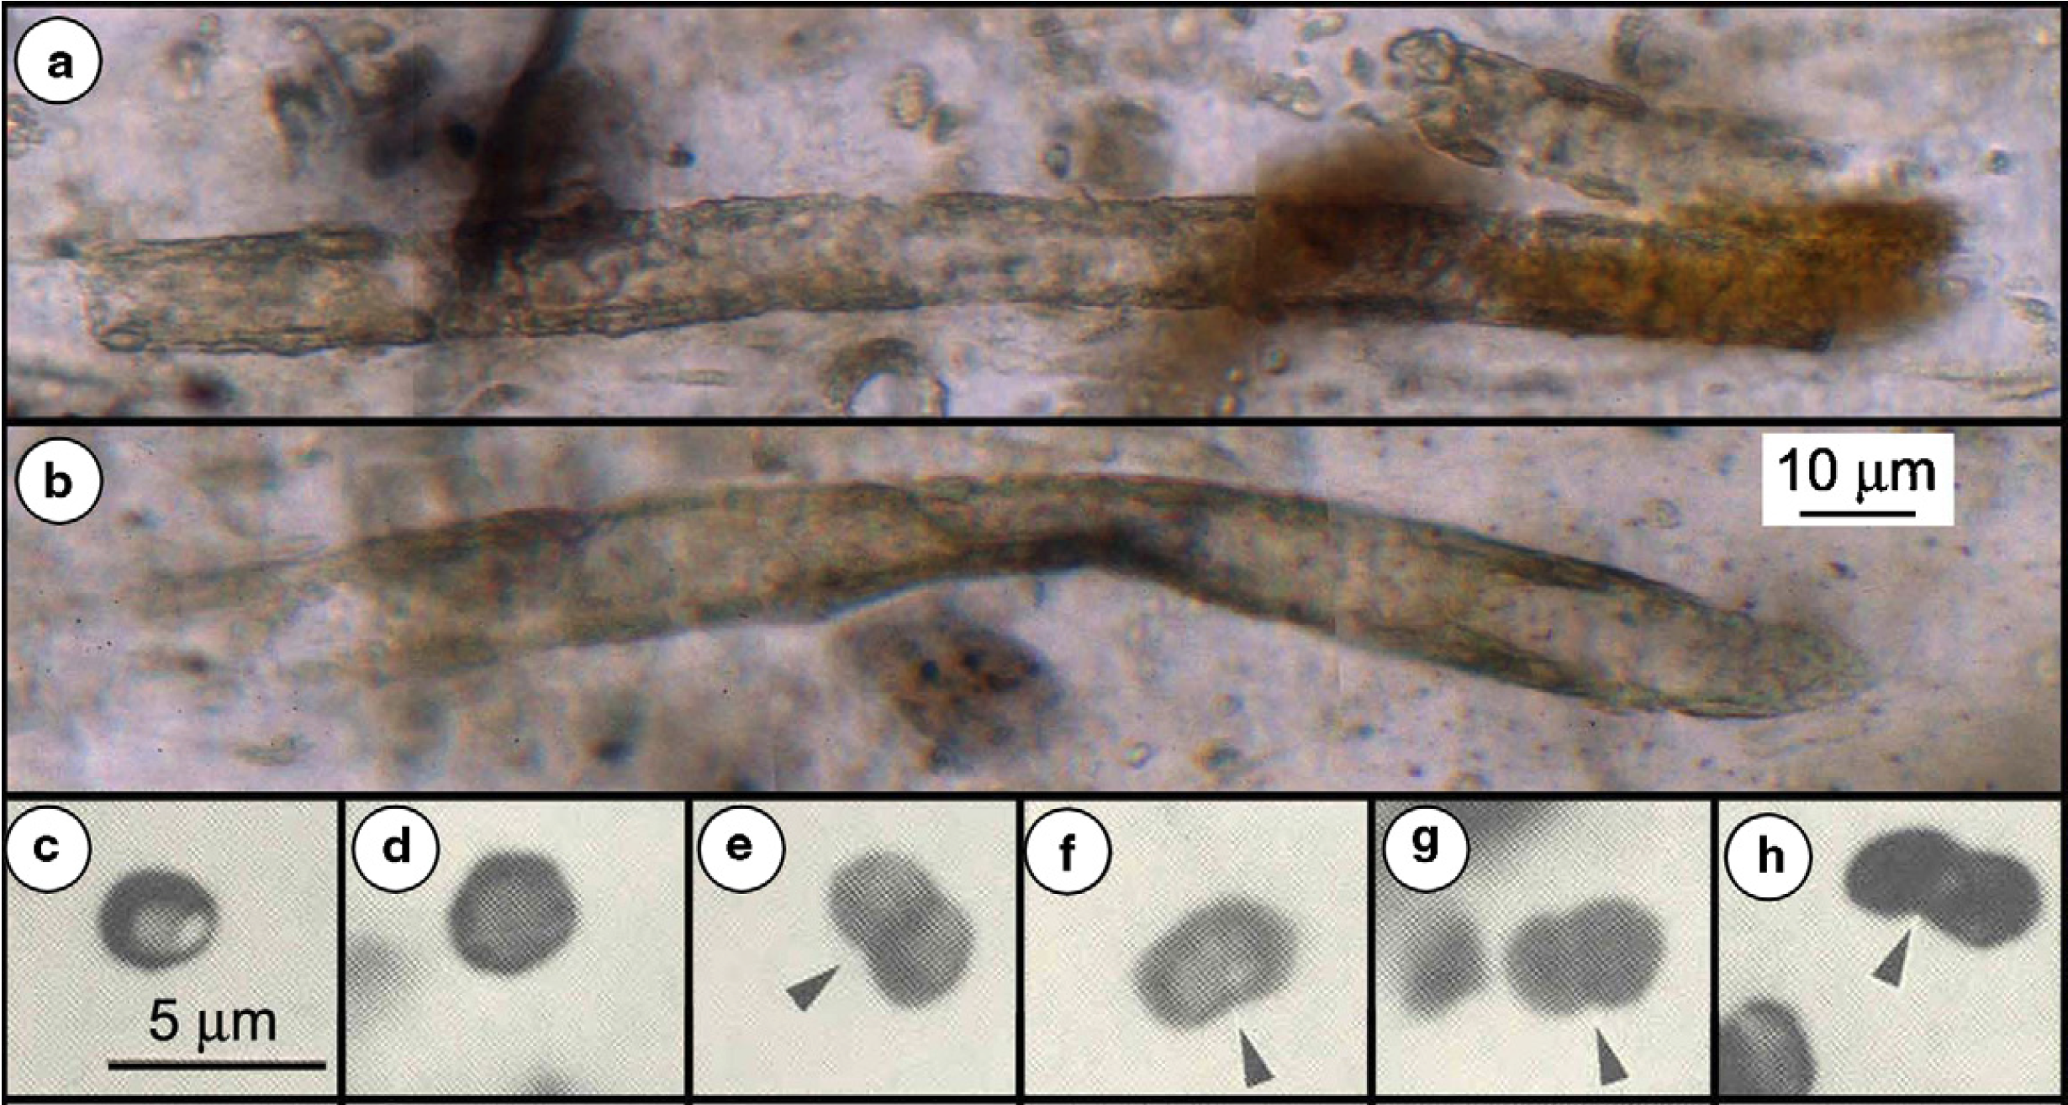

Fig. 2. Representative Archean microfossils in petrographic thin sections: (a and b) Broad prokaryotic (oscillatoriacean cyanobacterium-like) tubular sheaths (Siphonophycus transvaalense) from the ∼2516Ma Gamohaan Formation of South Africa; scale shown in (b). (c–h) Solitary or paired (denoted by arrows) microbial coccoidal unicells. Image form Schopf et al. 2007.

